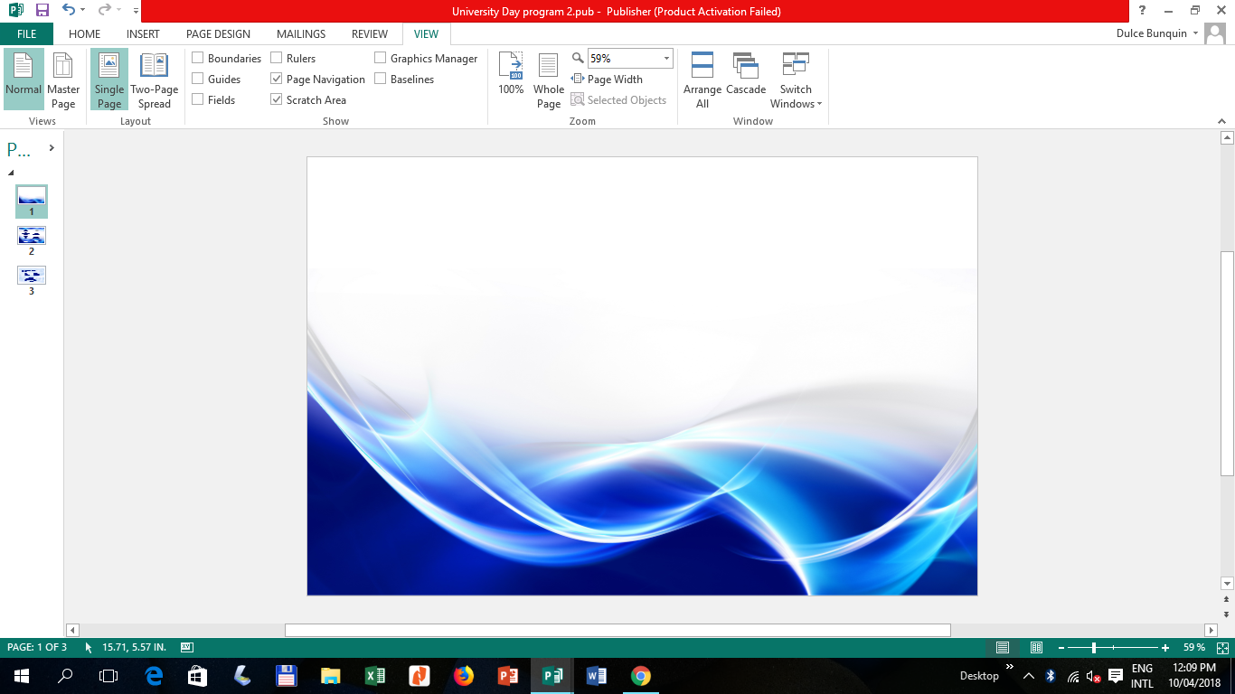



*A Strong Partner for Sustainable Development*

**Module**

**in**

**CHEM108**

**CHEMISTRY FOR ENGINEERS**

**COLLEGE OF ARTS AND SCIENCES**

Bachelor of Science in Agricultural

and Biosystems Engineering

*-Engineering-*

Module No. **1**

**Introduction to Chemistry:**

**Matter and Measurement**

**(Answer Sheet)**

1st Semester 2020-2021

**SHARON-JULLY P. UNTALAN, RCHE, ENP, MBA**

Instructor I

TABLE OF CONTENTS

|  |  |
| --- | --- |
| Title Page |  |
| Table of Contents |  |
| Instruction to the User |  |
| Introduction |  |
| Chapter 1. Title |  |
| Overview |  |
| Learning Outcomes |  |
| Pre-Test |  |
| Lesson 1 |  |
| Lesson 2 |  |
| Lesson 3 |  |
| Lesson 4 |  |
| References |  |
| Chapter Exercises |  |
| Answer Key |  |
| Student Information |  |
| Vision, Mission and Core Values |  |

**Instruction to the User**

This module will provide you with an educational experience while independently accomplishing the task at your own time and pace. It also aims to ensure that learning is unhampered by health and other challenges. It covers the topic about the Introduction to Chemistry: Matter and Measurement.

Reminders in using this module.

1. Keep this material neat and intact.
2. Answer the pretest first to measure what you know and what to be learned about the topic discussed in this module.
3. Accomplish the activities and exercises as aids and reinforcement for better understanding of the lessons.
4. Answer the posttest to evaluate your learning.
5. Do not take pictures in any parts of this module nor post it to social media platforms.

Value this module for your own learning by heartily and honestly answering and doing the exercises and activities. Time and effort were spent in the preparation of this module so that your learning may continue amidst this Covid-19 pandemic.

**Introduction**

This module will serve as an alternative learning material to that of regular classroom teaching and learning delivery. The instructor will facilitate and explain the module to the students to achieve its expected learning outcomes, activities and to ensure that they will learn amidst of pandemic.

This material discusses the introduction to Chemistry for Engineers. It aims to teach you about Introduction to Chemistry: Matter and Measurement. It is very important that you cooperate by using this module page by page and completing all the given activities. At the end of the module, the learning outcome is evaluated based on the different tasks given to you.

Through your cooperation in this kind of flexible learning delivery, understanding chemistry in the study of matter, the changes it undergoes and the measurements used in chemistry is possible. It is expected that after using this module you will become well-oriented on the basics of chemistry and be aware that chemical principles operate in all aspects of our lives and everyday activities.

**Chapter 1**

**Title: Introduction to Chemistry: Matter and Measurement**

**Overview**

Chemistry is the heart of many changes we see in the world around us, and it accounts for the different properties we see in matter. As you progress in this study, you will come to see how chemical principles operate in all aspects of our lives, from everyday activities like food preparation to more complex processes such as those that operate in the environment.

**Learning Outcomes**

At the end of the chapter, you will be able to:

1. Distinguish among elements, compounds and mixtures
2. Identify symbols of common elements
3. Identify common metric prefixes
4. Demonstrate the use of significant figures, scientific notation and SI units in calculations
5. Employ dimensional analysis in calculations

**Pre-test**

**Instructions**: To test your prior knowledge, please answer the pre-test.

1. Define the 3 states of matter. *(Solid, liquid, gas)*
2. These substances cannot be decomposed into simpler substances. *(pure substances)*
3. What elements can exist naturally as diatomic? *(elements)*
4. Mixtures that are uniform throughout are called ____. *(compounds)*
5. Provide the chemical symbol of the following:
6. Carbon *(C)*
7. Magnesium *(Mg)*
8. Copper *(Cu)*
9. Silver *(Ag)*

6. ____ properties do not depend on the amount of sample being examined *(intensive)*

7. ____ properties depend on the amount of sample, with two examples being mass and volume. *(extensive)*

8. ____ is defined as the amount of mass in a unit volume of a substance. *(density)*

9. _____ is a measure of the hotness or coldness of an object. *(temperature)*

10. What is the SI base unit of length? *(meter)*

11. These mixtures do not have the same composition, properties, and appearance throughout. *(heterogeneous)*

12. Homogeneous mixtures are also called ________? *(solutions)*

13. What kind of change happens when a substance changes its physical appearance but not its chemical composition? *(physical change)*

14. What kind of change happens when a substance is transformed into a chemically different substance? *(chemical change)*

15. We can separate a mixture into its components by taking advantage of differences in their ____? *(properties)*

**LESSON 1. CLASSIFICATIONS OF MATTER**



**Activities/Exercises**

1. Distinguishing among Elements, Compounds, and Mixtures.

“White gold” contains gold and a “white” metal, such as palladium. Two samples of white gold differ in the relative amounts of gold and palladium they contain. Both samples are uniform in composition throughout. Use Figure 1.6 to classify white gold.

***Answer***

Because the material is uniform throughout, it is homogeneous. Because its composition differs for the two samples, it cannot be a compound. Instead, it must be a mixture, and it’s a homogeneous mixture due to uniform composition throughout.

1. Draw figures that represent the following:

2a. Pure element

2b. Pure compound

2c. Mixture of element and a compound

***Answer***

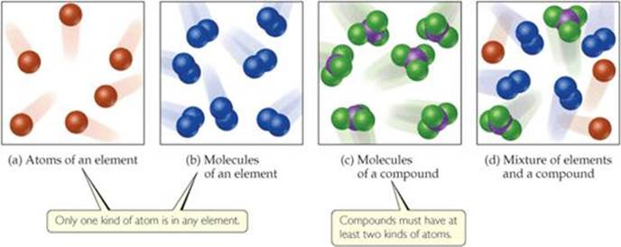

1. Provide the chemical symbol of the following elements:

3a. Mercury (*Hg*)

3b. Iron (*Fe*)

3c. Tin (*Sn*)

3d. Lead (*Pb*)

**Evaluation/Post-test**

1. What is a matter that has distinct properties? *(pure substances)*
2. These substances are composed of two or more elements; they contain two or more kinds of atoms. *(compounds)*
3. Name the French chemist who introduced the law of constant composition or the law of definite proportions *(Joseph Louis Proust)*
4. What is the difference between homogeneous and heterogeneous mixtures? Give one example for each mixture.

***Answer***

*Homogeneous mixtures - these mixtures are uniform throughout. Example: air is a homogeneous mixture of nitrogen, oxygen, and smaller amounts of other gases.*

*heterogeneous mixtures - these mixtures do not have the same composition, properties, and appearance throughout. Rocks and wood are examples.*

1. Classify whether the following substances are pure substance or a mixture. If it is a mixture, indicate whether it is homogeneous or heterogeneous.

a. calcium *(pure)*

b. lake water *(heterogeneous mixture)*

c. chocolate *(homogeneous mixture)*

**LESSON 2. PROPERTIES OF MATTER**

**Activities/Exercises**

1. Identify and explain the change that happened in the following example
2. Plants make sugar from carbon dioxide and water. *(chemical)*
3. Water vapor in the air forms frost. *(physical)*
4. Label the following as either physical process or chemical process
5. Boiling a pot of water *(physical)*
6. Rusting of a nail *(chemical)*
7. Digesting a meal *(chemical)*

**Evaluation/Post-test**

1. _____ properties describe the way a substance may change or react to form other substances. *(chemical properties)*
2. What is the method used in separating the components of a homogeneous mixture? *(distillation process)*
3. Give 3 examples of physical properties of matter
4. *Length*
5. *Color*
6. *Odor*
7. Describe the separation methods involved in brewing coffee

*Extraction and filtration methods*

**LESSON 3. UNITS OF MEASUREMENT**

**Activities/Exercises**

Using SI Prefixes

(1) Find the name of the unit that equals the following:

(a)10–9 gram

(b)10–6 second

(c)10–3 meter

***Answers***

*We can find the prefix related to each power of ten in Table 3.2:*

*(a) nanogram, ng*

*(b) microsecond, μs*

*(c) millimeter, mm*

(2) (a) How many picometers are there in one meter? (b) Express 6.0 × 103 using a prefix to replace the power of ten. (c) Use exponential notation to express 4.22 mg in grams. (d) Use decimal notation to express 4.22 mg in grams.

***Answers****: (a)1012 pm, (b)6.0 km, (c)4.22 × 10–3 g, (d)0.00422 g*

Converting Units of Temperature

(3) A weather forecaster predicts that the temperature will reach 31 °C. What is this temperature in K?

**Answer**: Using Equation 1.1, we have K = 31 + 273 = 304 K.

**Evaluation/Post-test**

Include the solution in answering the following problems:

1. Calculate the density of a 374.5-g sample of copper if it has a volume of 41.8 cm3.

***Answer****: (1) 8.96 g/cm3*

1. A student needs 15.0 g of ethanol for an experiment. If the density of ethanol is 0.789 g/mL, how many milliliters of ethanol are needed?

***Answer****: (1) 19.0 mL*

1. What is the mass, in grams, of 25.0 mL of mercury (density = 13.6 g/mL)?

***Answer****: 340 g*

1. Ethylene glycol, the major ingredient in antifreeze, freezes at –11.5 °C.

What is the freezing point in (a) K, (b) °F?

***Answers****: (a) 261.7 K, (b) 11.3 °F*

(5) Convert English Units to SI Units. Show your solution.

a. 5 gal to liters

b. 15 lbs to grams

c. 70 ft to meters

d. 50 oz to grams

***Answer****: Use table 3.4 for conversion factors*

**LESSON 4. UNCERTAINTY IN MEASUREMENT**

**Activities/Exercises**

Relating Significant Figures to the Uncertainty of a Measurement

(1) What difference exists between the measured values 4.0 g and 4.00 g?

***Answer***

***The value 4.0 has two significant figures, whereas 4.00 has three.*** *This difference implies that the 4.0 has more uncertainty. A mass reported as 4.0 g indicates that the uncertainty is in the first decimal place. Thus, the mass might be anything between 3.9 and 4.1 g, which we can represent as 4.0 ± 0.1g. A mass reported as 4.00 g indicates that the uncertainty is in the second decimal place. Thus, the mass might be anything between 3.99 and 4.01 g, which we can represent as 4.00 ± 0.01g.*

(2) How many significant figures are in each of the following numbers (assume that each number is a measured quantity): (a) 4.003, (b) 6.023 × 1023, (c) 5000?

***Answer***

*(a)* ***Four****; the zeros are significant figures*

*(b)* ***Four****; the exponential term does not add to the number of significant figures*

*(c)* ***One****; we assume that the zeros are not significant when there is no decimal point shown. If the number has more significant figures, a decimal point should be employed or the number written in exponential notation. Thus, 5000. has four significant figures, whereas 5.00 × 103 has three*

(3) A gas at 25 °C fills a container whose volume is 1.05 × 103 cm3. The container plus gas has a mass of 837.6 g. The container, when emptied of all gas, has a mass of 836.2 g. What is the density of the gas at 25 °C?

***Answer***

*To calculate the density, we must know both the mass and the volume of the gas. The mass of the gas is just the difference in the masses of the full and empty container:*

(837.6 – 836.2) g = 1.4 g

*In subtracting numbers, we determine the number of significant figures in our result by counting decimal places in each quantity. In this case, each quantity has one decimal place. Thus, the mass of the gas, 1.4 g, has one decimal place.*

*Using the volume given in the question, 1.05 × 103 cm3, and the definition of density, we have*

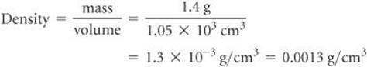

*In dividing numbers, we determine the number of significant figures in our result by counting the number of significant figures in each quantity. There are two significant figures in our answer, corresponding to the smaller number of significant figures in the two numbers that form the ratio. Notice that in this example, following the rules for determining significant figures gives an answer containing only two significant figures, even though each of the measured quantities contained at least three significant figures.*

(4) To how many significant figures should the mass of the container be measured (with and without the gas) in Exercise 3 for the density to be calculated to three significant figures? Explain why.

***Answer****:* ***five***

*For the difference in the two masses to have three significant figures, there must be two decimal places in the masses of the filled and empty containers. Therefore, each mass must be measured to five significant figures.*

*Note: When a calculation involves two or more steps and you write answers for intermediate steps, retain at least one nonsignificant digit for the intermediate answers. This procedure ensures that small errors from rounding at each step do not combine to affect the final result. When using a calculator, you may enter the numbers one after another, rounding only the final answer. Accumulated rounding-off errors may account for small differences among results you obtain and answers given in the text for numerical problems.*

1. Evaluation/Post-test

(1) A sample that has a mass of about 25g is placed on a balance that has a precision of ± 0.001g. How many significant figures should be reported for this measurement?

***Answer****:* ***five***

*As in the measurement 24.995 g or 25.000 g, the uncertainty being in the third decimal place*

(2) How many significant figures are in each of the following measurements:

(a) 3.549 g, (b) 2.3 × 104cm, (c) 0.00134 m3?

***Answers****: (a) four, (b) two, (c) three*

(3) The width, length, and height of a small box are 15.5 cm, 27.3 cm, and 5.4 cm, respectively. Calculate the volume of the box, using the correct number of significant figures in your answer.

***Answer***

*In reporting the volume, we can show only as many significant figures as given in the dimension with the fewest significant figures (that for the height, 5.4 cm, with two significant figures):*

**

*Note: A calculator used for this calculation shows 2285.01, which we must round off to two significant figures. Because the resulting number is 2300, it is best reported in exponential notation, 2.3 × 103, to clearly indicate two significant figures.*

(4) It takes 10.5 s for a sprinter to run 100.00 m. Calculate her average speed in meters per second, and express the result to the correct number of significant figures.

***Answer****: 9.52 m/s*

*Three significant figures following 10.5 s with the least number of significant figures*

**LESSON 5. DIMENSIONAL ANALYSIS**

Activities/Exercises

1. If a woman has a mass of 115 lb, what is her mass in grams? (Use the relationships between units)

***Answer***

*Because we want to change from pounds to grams, we look for a relationship between these units of mass. The conversion is 1 lb = 453.6 g. To cancel pounds and leave grams, we write the conversion factor with grams in the numerator and pounds in the denominator:*

**

*The answer was given to only three significant figures, following the same number of significant figures in 115 lb.*

1. Determine the length in kilometers of a 500.0-mi automobile race.

***Answer****: 804.7 km (1 mi = 1.6093 km)*

1. The average speed of a nitrogen molecule in air at 25 °C is 515 m/s. Convert this speed to miles per hour (mi/hr).

**Answer**

To go from the given units, m/s, to the desired units, mi/hr, we must convert meters to miles and seconds to hours.

From our knowledge of SI prefixes, we know that 1 km = 103 m. From the relationships given earlier, we find that 1 mi = 1.6093 km.

Thus, we can convert *m* to *km* and then convert *km* to *mi*. From our knowledge of time, we know that 60s = 1 min and 60 min = 1hr. Thus, we can convert seconds to minutes and then convert minutes to hours.

The overall process is

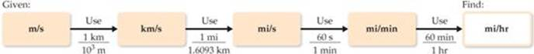

Applying first the conversions for distance and then those for time, we can set up one long equation in which unwanted units are canceled:

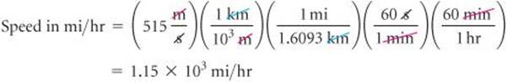

1. Evaluation/Post-test
2. If the volume of an object is reported as 5.0 ft3, what is the volume in cubic meters?

***Answer****:* ***0.14m3****(1 ft = 0.305 m)*

*50 ft3 x [(0.305 m) 3/(1 ft) 3] = 0.14 m3*

1. A car travels 28 mi per gallon of gasoline. How many kilometers per liter will it go?

***Answer****:* ***12 km/L*** *(1 mi = 1.6093 km, 1 gal = 3.79 L)*

*28 mi/gal x (1.6093 km/1 mi) x (1 gal /3.79 L) = 12 km/L*

1. Earth's oceans contain approximately 1.36 × 109 km3 of water. Calculate the volume in liters.

***Answer***

*From the back inside cover, we find 1 L = 10–3 m3, but there is no relationship listed involving km3. From our knowledge of SI prefixes, however, we know 1 km = 103 m and we can use this relationship between lengths to write the desired conversion factor between volumes:*

**

*Thus, converting from km3 to m3 to L, we have:****1.36 x 1021 L***

**

Reference

Brown, Theodore L. et.al. (2015). Chemistry: The Central Science

**Rubric for essays and discussions:**

|  |  |  |  |
| --- | --- | --- | --- |
| **Features/Score** | **1 (0%)** | **3 (50%)** | **5 (100%)** |
| Content/Ideas, 50% | No answer | Identified the topic and provided additional information | Presented important and accurate information |
| Quality of writing,  30% | No answer | The information presented was somewhat organized and clear | The idea presented was organized and highly informative |
| Grammar and usage, 20% | No answer | Multiple spelling and grammatical errors | Virtually no spelling or grammatical errors |



**Congratulations for completing this module!**

**Student’s Information**

Name:

Program:

Year and Section:

Contact No.:

E-mail address:

Facebook Account:

Messenger Account:



**Vision 2020**

WPU: the leading knowledge center for sustainable

development of West Philippines and beyond.

**Core Values (3CT)**

Culture of Excellence

Commitment

Creativity

Teamwork

**Mission**

WPU commits to develop quality human resource and green technologies for a dynamic economy and sustainable

development through relevant instruction,

research and extension services.